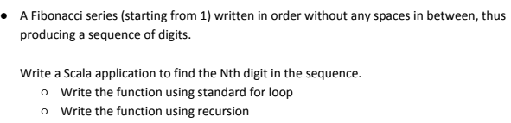

**Screenshot of Program:-**

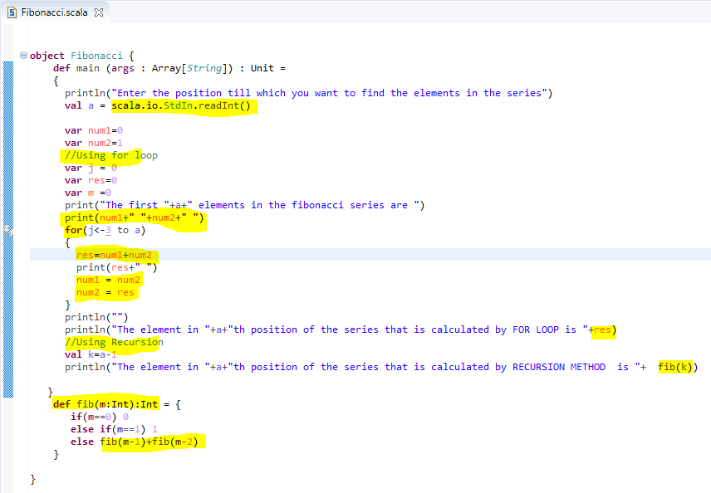

**SAMPLE OUTPUT 1:-**

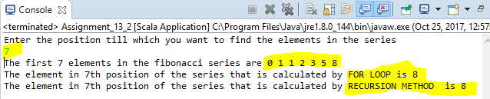

**SAMPLE OUTPUT 2:-**

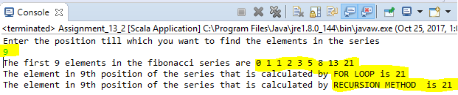

**Program code:-**

**object** Fibonacci {

**def** main (args : Array[*String*]) : Unit =

{

println("Enter the position till which you want to find the elements in the series")

**val** a = scala.io.StdIn.readInt()

**var** num1=0

**var** num2=1

//Using for loop

**var** j = 0

**var** res=0

**var** m =0

print("The first "+a+" elements in the fibonacci series are ")

print(num1+" "+num2+" ")

**for**(j<-3 to a)

{

res=num1+num2

print(res+" ")

num1 = num2

num2 = res

}

println("")

println("The element in "+a+"th position of the series that is calculated by FOR LOOP is "+res)

//Using Recursion

**val** k=a-1

println("The element in "+a+"th position of the series that is calculated by RECURSION METHOD is "+ fib(k))

}

**def** fib(m:Int):Int = {

**if**(m==0) 0

**else** **if**(m==1) 1

**else** fib(m-1)+fib(m-2)

}

}